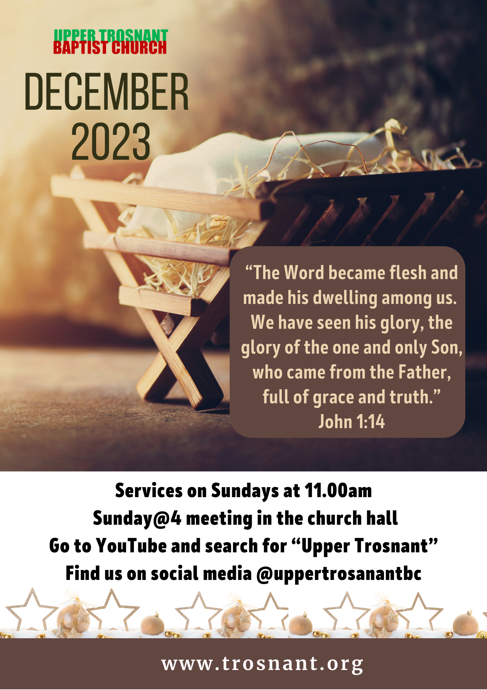
Contents
Letter from Pastor Richard: Peace on Earth? |  | 2
Doreen’s Page: Christmas Dinner |  | 4
CHRISTMAS FEATURES AND ARTICLES  - A Christmas Poem: ‘the gift of God’s love’  - Advent and Christmas Dates for your Diaries  - ‘A Carol is not just for Christmas!’ by Clare Hopkins  - Bible Notes 34: The Wise Men, by Daniel Pearson  - ‘Christmas Socks’, by Daniel Pearson  - Christmas Wordsearch |  | 5  6  7  9  11  12
FOCUS ON MISSION: Working for the Lord in Albania |  | 13
UPPER TROSNANT NEWS  - Upper Trosnant Update  - CHURCH DIARY for December  - ROTAS for December  - Birthdays in December |  | 14  15  16  18
PRAYER PAGES  - Prayers in the Christmas Season  - Please pray for… |  | 17  18
You are invited to – Carols by Candlelight | Back page
Contact Details | Back page

Newsletter Items:

We are always happy to receive items for the newsletter.
Please email articles or features for the January 2024 edition to uppertrosnantbc@gmail.com by
Sunday 10th December.

1
Letter from Pastor Richard

Peace on Earth

Once again, Christmas is fast approaching. As Annmarie and I were discussing recently, from the middle of November time seems to accelerate. There is always the thought – will I get everything done in time?

In addition to the usual hustle and bustle, this year’s Christmas takes place in a context of much unrest in the world. For nearly 2 years now, we have been very concerned about what has been happening in Ukraine. It has been out of the headlines recently, but there is still an ongoing conflict in that country. And of course, over the past couple of months we have been made aware of the war between the Israelites and the Palestinians. We continue to pray that a solution will be found that is just and equitable.

These are just a couple of examples of tension in our world. And here we are talking about the Lord Jesus Christ coming into this world as we read words like this:
For to us a child is born,
to us a son is given,
and the government will be on his shoulders.
And he will be called
Wonderful Counsellor, Mighty God,
Everlasting Father, Prince of Peace. (Isaiah 9 v 6 (NIV))

And we look at that last phrase, Prince of Peace, and we say “How does that work? You’re telling me that Jesus came into the world, just over 2000 years ago, and he came as the Prince of Peace! There have been wars ever since, not to mention what is going on at the moment.”

I still say to you, Jesus did come as the Prince of Peace. He came to bring peace between human beings and God. The peace that was broken when Adam and Eve rebelled in the Garden of Eden. At Christmas, we remember Jesus’ birth in a manger in Bethlehem. He came to sort out what had gone wrong between humans and God. He did that by living
2
a perfect life, and yet at the end being put to death on a cross. As he was there, he took upon himself all those things that are not pleasing to God so that we can be forgiven. Now there can be peace between God and people as they put their trust in what Jesus did.

But where does that leave the world in its current situation? We need to pray that God will put it in the hearts of those who want to cause war and conflict to, instead desire peace. As they seek God, and trust in Jesus, they will not want to fight; they will want to live peacefully with each other. And so, as we celebrate the birth of the Lord Jesus Christ, let’s pray that those involved in conflict situations will seek him as the Prince of Peace, and put an end to all the fighting. In the words of one of our lesser-known carols:

With sorrow brought by sin and strife
the world has suffered long
and, since the angels sang, have passed
two thousand years of wrong:
the nations, still at war, hear not
the love-song which they bring:
O hush the noise and cease the strife,
to hear the angels sing! Edmund H. Sears

A very Happy Christmas to you all.
Love in Jesus, Pastor Richard

The Advent Theme – “Our God contracted to a span”
This is a phrase taken from the Charles Wesley hymn “Let earth and heaven combine”, which we will be singing over the Advent season. We are focussing upon the fact that the Lord Jesus Christ left the glory of heaven to come down to the world and humble himself so that we can be forgiven and brought to God. This theme will form the basis of the Sunday morning ministry, using these Scriptures – you might want to read them in advance:

3rd December: Let earth and heaven combine – Philippians 2: v 6–11
10th December: Thou who wast rich – 2 Corinthians 8 v 9
17th December: Thou didst leave Thy throne – 1 Timothy 1 v 15
3
Doreen’s Page: Christmas Dinner

This year, as the countdown to Christmas begins with a ploughman’s lunch on 2 December (all are invited – see page 6), this reflection from Doreen’s book Daffodils in Winter gives us some tasty food for thought!

Christmas dinner is often described as, “the meal of the year.” Christmas food is traditional and for centuries we have feasted on turkey, Christmas pudding and mince pies. Turkey came to UK tables in 1526. King Henry VIII is recorded as having eaten it with enthusiasm at Christmas – although his size would indicate that he always enjoyed his food! These days it is estimated that 10 million turkeys are roasted and relished in the UK each year.

In the 14th Century, a porridge called frumenty, made from best mutton, raisins, currants, spices, and prunes was served on Christmas Eve. In the 1950s it was still traditional food in some farming communities. The recipe changed, in content and shape, but frumenty is the origin of Christmas pudding. Mince pies were introduced in the 13th Century. Crusaders brought the recipe back from their war in the Middle East. The recipe included minced meat, flavoured with alcohol, fruit and spices to preserve the meat. Other names were Shrid pies or Crib pies – shaped like a cradle, to remind the eater that Jesus was born at Christmas, and Wayfarers pies, because they were offered to visitors and travellers at Christmas. An old tradition started that the year ahead would be a good year if you ate a mince pie on each of the 12 days of Christmas. It is estimated that over 300 mince pies are eaten over the Christmas period today. If you are interested in numbers, maybe 9,875 tonnes of sprouts will accompany the 10 million turkeys!

With these facts and figures in mind, please consider the Bible verse, “Taste and see that the Lord is good. Blessed is the man who takes refuge in Him.” (Psalm 34:8.) Christmas is THE time for celebration. It is the greatest anniversary of all time. The fact of Christmas is that God so loved the world that He sent His own son, Jesus, to be the saviour of the World. When Jesus was born in Bethlehem, angels descended from heaven and celebrated in song. The fact deserved a feast! Consider another verse from the Psalms: “Oh, magnify the Lord with me, and let us exalt his name together!” (Psalm 34:4.)
4
A Christmas Poem:

The Gift of God’s Love
by Helen Steiner Rice

“And she gave birth to her first-born son and wrapped him in swaddling clothes, and laid him in a manger, because there was no place for them in the inn.” (Luke 2 verse 7.)

All over the world at this season,
expectant hands reach to receive
gifts that are lavishly fashioned,
the finest that Man can conceive.
For, purchased and given at Christmas
are luxuries we long to possess,
given as favours and tokens
to try in some way to express
that strange, indefinable feeling
which is part of this glad time of year
when streets are crowded with shoppers
and the air resounds with good cheer.
But back of each tinsel-tied package
exchanged at this gift-giving season,
unrecognised often by many,
lies a deeper, more meaningful reason.
For, born in a manger at Christmas
as a gift from the father above,
an infant whose name was called Jesus
brought mankind the gift of God’s love.
And the gifts that we give have no purpose,
unless God is part of the giving,
and unless we make Christmas a pattern,
to be followed in everyday living.

A Christmas Prayer: No place for you in the inn? Welcome to my heart, I want to keep a favourable spot always ready for you, Jesus.

Chosen for the Newsletter by Rhoswyn
5
Advent and Christmas Dates for your Diaries
What’s on at Upper Trosnant
Christmas Ploughman’s Lunch
Saturday 2nd December at 1.30
- Everyone is welcome; please sign up in the hall or via the Church contact details.

Carol Singing for our Friends and Neighbours
Wednesday 6th December, 7 pm.
- Wrap up warm - we will be singing outdoors at Aneurin Bevan Court and in Trosnant Villas.
- If you see us, please give us a wave from your window, pop out and join in, or come back to the hall for some hot drinks.
Carols by Candlelight
Sunday 17th December at 4.00
- Followed by tea coffee and mince pies.
- See the back page for details – everyone is welcome – just turn up!

Sisterhood Christmas Party
Tuesday 19th December at 2.30 – 4 pm in the Hall
- Always the biggest Sisterhood Event of the year!
- Friends and new members are especially welcome. Please speak to Annmarie or contact her via the details on the back page.

Christmas Day Worship
December 25th, 10.00 – 10.45 am
- Please join us for a joyful time celebrating the birth of Jesus with carol singing and a special message brought to us by David Breese.

What’s on in Pontypool
Carol Singing in the Market
Wednesday 6th December: 10.30 am

Carol Singing in Pontypool Town Centre
Saturday 16th December: 11.00 am
Everyone is warmly invited to join with friends from Churches United in Pontypool.
6
A Carol is not just for Christmas

One afternoon at Sisterhood in October, Doreen suggested that we sing an old Christmas favourite, “Thou didst leave thy throne and thy kingly crown”. It was sung with great gusto, and afterwards everyone agreed how much they had enjoyed it, and what a shame it is that we usually only sing “Christmas” songs in December…

When I thought about the words of this “carol”, however, I soon realised that although it begins with the birth of Jesus, it quickly moves on to tell the whole story of his life – “thy couch was the sod [i.e. he slept on the ground] in the deserts of Galilee” – his death – “with mocking scorn and with crown of thorn, they bore thee to Calvary” – and his second coming – “Heavens arches shall ring, and her choirs shall sing at thy coming to victory”. It is not about what happened, but why.

I was surprised to learn that these words were originally written for children to sing! The author, Emily Elliot, was born in 1836 in Brighton, where her father was the Rector of St Mark’s parish. Throughout her life she worked with evangelical rescue missions and Sunday Schools in her local area. Emily wrote this song in 1864 and had it printed privately for the children’s choir of her father’s parish. It was published in 1870. Some of the words seem difficult and old-fashioned to us, but at that date the only Bible in use was the King James, and to say ‘thee’ and ‘thou’ was simply the way that everyone talked to God in prayer.

Emily was a very talented poet. Each verse draws a contrast. In the first two it is between Heaven – “thy throne, and thy kingly crown” – and earth, where there was ‘no room’ at the inn and Jesus experienced a ‘lowly birth’. When he was tempted in the wilderness, Jesus was exposed in the desert, while even the wild animals had more shelter. He was ‘the living Word’ offering freedom from sin, but instead was rejected and crucified. It is common for carols to be written in the voice of the whole congregation – “Oh come let us adore him”, for instance – or as a celebration of the Christmas story – “Hark, the herald angels sing”. But these words are very personal and can be read or sung as a prayer. Although there was no room for Jesus at the inn, we can make room for him in our own lives. The first three verses end simply, “Oh come to my heart Lord Jesus, there is room in my heart for thee.” The fourth verse recognises Jesus as Saviour: “thy
7
cross is my only plea.” And finally, we can look forward to being with him in heaven, “My heart shall rejoice Lord Jesus, when thou comest and callest for me!” Clare Hopkins

Thou didst leave Thy throne and Thy kingly crown

Thou didst leave Thy throne and Thy kingly crown,
When Thou camest to earth for me;
But in Bethlehem’s home was there found no room
For Thy holy nativity:
Oh, come to my heart, Lord Jesus!
There is room in my heart for Thee.

Heaven’s arches rang when the angels sang,
Proclaiming Thy royal decree;
But of lowly birth cam’st Thou, Lord, on earth,
And in great humility:
Oh, come to my heart, Lord Jesus, come,
There is room in my heart for Thee.

The foxes found rest, and the birds had their nest
In the shade of the forest tree;
But Thy couch was the sod, O Thou Son of God,
In the deserts of Galilee:
Oh, come to my heart, Lord Jesus, come,
There is room in my heart for Thee.

Thou camest, O Lord, with the living Word
That should set Thy people free;
But with mocking scorn, and with crown of thorn,
They bore Thee to Calvary:
Oh, come to my heart, Lord Jesus!
Thy cross is my only plea.

When heaven’s arches shall ring, and her choirs shall sing
At Thy coming to victory,
Let Thy voice call me home, saying, “Yet there is room,
There is room at My side for thee!”
And my heart shall rejoice, Lord Jesus!
When Thou comest and callest for me.
8

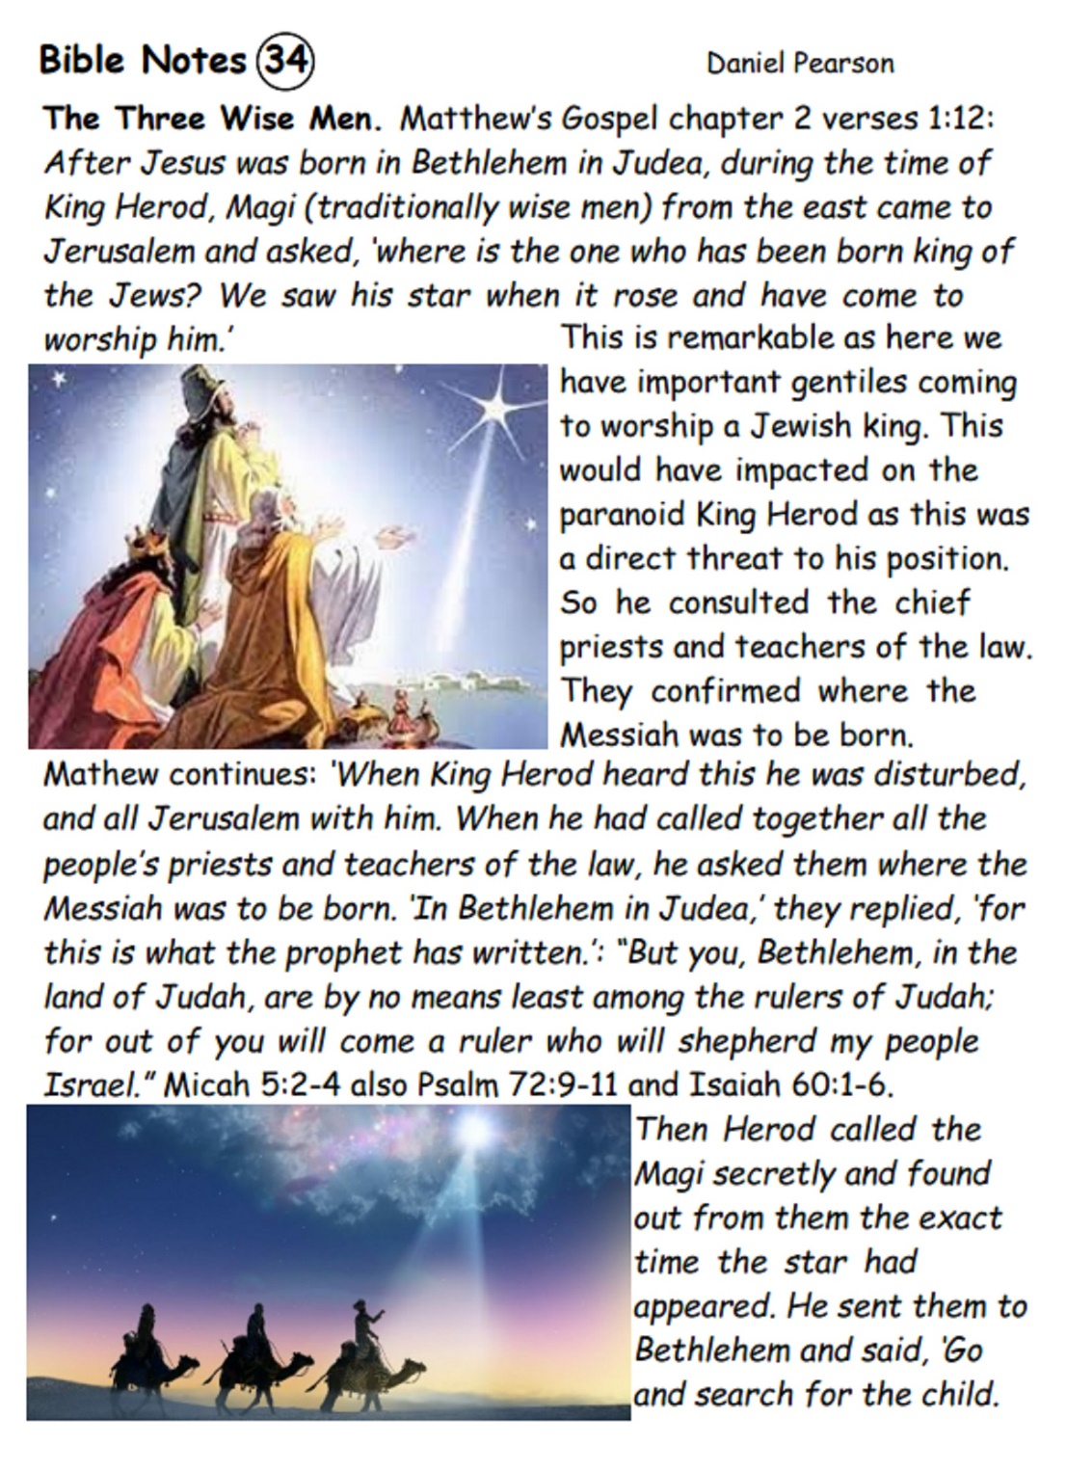
9

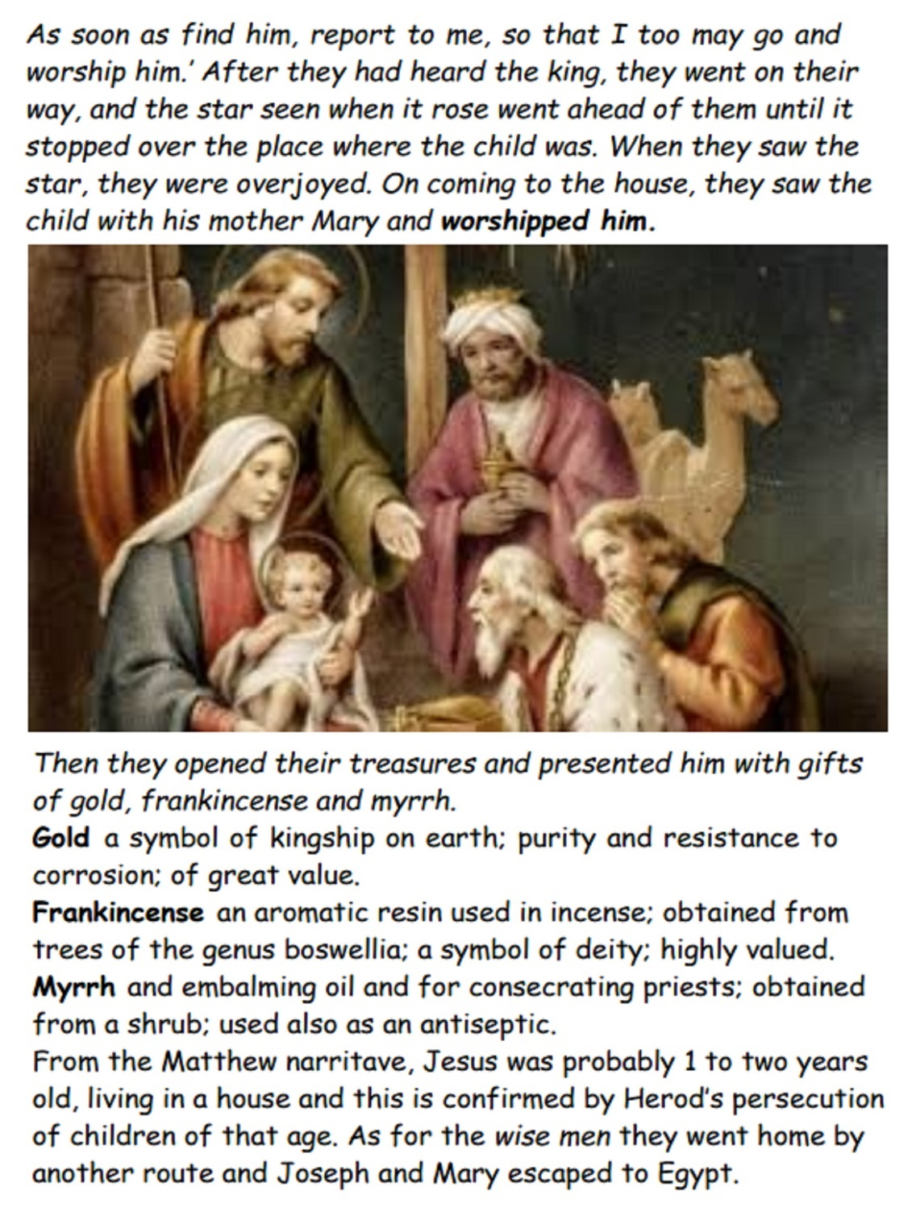
10
My Christmas Socks

What would you like for Christmas? Is a common enough question and one I usually fail to answer. But one year my daughter didn’t even ask – she appeared with three pairs of JCB socks. I asked how she knew what I needed? The answer was obvious. While I spent five weeks in hospital, she had tided my bedroom and sorted out my sock drawer and saw that more working socks were needed.
Now I slide my feet into JCB socks each morning and think of the love and care my daughter showed and how I value her and her gift. I am reminded each morning that God gave me a gift – the gift of another day and the gift of Jesus Christ as my saviour; a free gift, like my socks, but unlike my socks, it is life changing. As my feet fill my socks so I know that the Lord fills me with His Holy spirit. The Spirit gives me the assurance of God’s love for each step I take and, as I step out each morning, I am confident that I am following a path the Lord has for me.

My socks are not alone – I have my feet in them, and they go where I’m going. And I’m not alone; I have God’s word, the Bible, to guide me where the Lord wants me to go and I can call for directions at any time through the gift of prayer and I can praise Him for all his gifts to me – including my socks and my daughter.

I look back and see the path; how clearly my life has changed along the narrow way. My shortcomings are no longer a burden and I delight in the word of the Lord. I am guided by the Lord in what I do and how I do it; in what I think and what I say and long that everyone will have the gift of the Gospel - the socks are optional!

Good as the socks are as a reminder, the sock analogy is limited. Soon, as is common with socks they will become holey – whereas the gifts of God are everlasting and Holy.
Daniel Pearson
11
Christmas Wordsearch

Eight hundred years before Jesus was born, Isaiah prophesied the coming of the Messiah. Can you find the words written in bold in the grid below? The letters you have left, read from top to bottom and left to right will spell out the name of a popular Christmas carol.

S | S | E | N | S | U | O | E | T | H | G | I | R | P
E | S | T | A | B | L | I | S | H | I | N | G | E | T
C | H | S | T | N | E | M | N | R | E | V | O | G | A
H | O | R | E | H | T | A | F | Y | E | P | N | C | U
L | U | U | D | N | A | L | T | F | L | I | C | K | P
U | L | T | N | O | K | H | G | E | T | O | D | I | H
F | D | H | I | S | G | R | C | S | M | R | E | N | O
R | E | G | S | I | E | I | A | P | T | M | N | G | L
E | R | I | M | A | T | L | L | D | I | N | W | D | D
D | S | L | T | S | R | I | L | T | A | O | A | O | I
N | A | W | U | E | S | D | R | O | L | V | D | M | N
O | E | J | V | H | E | C | N | I | R | P | I | L | G
W | R | E | V | E | R | O | F | C | H | I | L | D | L
E | C | A | E | P | G | R | E | A | T | N | E | S | S

The people walking in darkness have seen a great light; On those living in the land of deep darkness a light has dawned. For to us a child is born, to us a son is given, and the government will be on his shoulders. And he will be called Wonderful Counsellor, Mighty God, Everlasting Father, Prince of Peace. Of the greatness of his government and peace there will be no end. He will reign on David’s throne and over his kingdom, establishing and upholding it with justice and righteousness from that time on and forever. The zeal of the Lord Almighty will accomplish this. (Isaiah 9: verses 2 and 6-7.)
12
Mission Focus: Working for the Lord in Albania

At the Church Meeting in October, members discussed whether Upper Trosnant might partner with BMS workers in Albania. Situated on the Balkan peninsula, Albania has a tumultuous history of invasions and occupation, and remains one of the poorest countries in Europe with many economic and social difficulties. The population of less than 3 million comprises 62% Muslim, and about 30% orthodox Christians.

Annie and Dan Dupree have worked with MBS World Mission in the capital, Tirana, since 2014. They run a charity, Tek Ura, which works with some of the poorest and most marginalised people in Europe. The name means ‘at the bridge’ and Tek Ura is an inclusive community centre, a provider of health, education and welfare services, and a church. Dan is a Baptist minister and Anne a physiotherapist. Tek Ura runs camps and skills training for families and young people; works to develop young leaders; teaches English; hosts a ‘Recovery Club’, which helps people out of sustained unemployment and crisis into an occupation, or out of illicit employment to legal work.

This is how Dan and Annie described last Christmas at Tek Ura: “We approached the festive season there, unsure of what might happen, wondering whether anyone in the community would come to our celebrations. Amazingly, more than 100 people came, families from projects we have started, new neighbours, some curious about our approach, many hearing the nativity for the very first time. We see opportunities for responding in hope to those families, to intentionally love that place that so many people want to leave, and to point to a God already at work, here in our midst. We ask for you to pray as we seek to join in with God's mission, reaching out to these people, developing community and being a hopeful and positive presence.”
Since the Church meeting, we have learned that the Duprees will be completing their term of service in Albania in 2024 and so are unable to partner with any new churches. Let us pray for their last Christmas and final months in the country, and ask that all the works they have begun can be continued by local Christian workers.
13
Upper Trosnant Update
- Many people look forward to the Advent and Christmas season. It is a busy and yet exciting time as we remember and celebrate the birth of the Lord Jesus Christ.
- Our Sunday @ 4 meetings are being appreciated by those who have come. It has been good, in a more informal setting to enjoy fellowship together. As well as Facebook Live and Communion we have had the opportunity to ask questions regarding the Sunday sermons, focussing on The Holy Spirit. These have been extremely useful in increasing understanding and how to apply God’s Word in our lives.
- There will be a 2-part Advent series in Sunday @ 4: 1. Where did Jesus come from? 2. Why did Jesus come? This will be in the format of Facebook Live followed by discussion.
- Warm Space and Open House continue to go well. Those who come are enjoying tea/coffee and cake as well as good conversation.
- There was a Sisterhood meal out which was enjoyed by those who went. This meeting is a real encouragement; the fellowship, prayer and appetite for the Word is great to see.
- We had a full hall for the AGM of the Gwent Baptist Association. Many of the churches were represented there. It was a real joy to sing God’s praises together and renew fellowship with Christian Williams, who has become a good friend to us as a church. He spoke about the Church as described in Acts 2 v 42 – 47 and the implications for our present situation. He gave examples from his own experience to help us.
- The Spirit Choir will have visited by the time you read this. We will report on the event in the next Newsletter.
- Prayer meetings for Christians Against Poverty (CAP) have re-started. They take place on the second Tuesday of each month at 9.30 am in our hall. The next one is on 12th December; all are welcome.
- Please note that Pastor Richard and Annmarie will be on Annual leave from Friday 22nd December to Monday 1st January (inclusive). The premises will be closed from 24th Dec to 1st Jan (apart from services).
- A big thank you to all who helped with the cleaning afternoon in November, and thanks in anticipation to those who will help to decorate the church and hall for Christmas.
14
CHURCH DIARY FOR DECEMBER

Sunday Services and Preachers
11.00 am: In the Church building and later on YouTube;
followed by Tea and Coffee in the Hall.

3rd | Pastor Richard (Communion)
10th | Pastor Richard
17th | Pastor Richard (Communion)
24th | Christmas Eve – Richard Harrison
31st | New Year’s Eve – Richard Harrison

Sunday Afternoons @ 4 o’clock
Meeting together in the Hall, with tea and coffee.

3rd | Advent 1 with Pastor Richard
10th | Advent 2 with Pastor Richard
17th | CAROLS BY CANDLELIGHT – see back page
24th and 31st No afternoon meeting

Monday
4th and 18th – Warm Space 2.00–4.00 pm in the Hall. Everyone is warmly invited to drop in for a friendly chat over a nice cup of tea or coffee and biscuits. There may be cake too!

11th – Open House – We play games or share crafts, or just meet for a cup of tea and a chat.

4th – 2.00 pm – Carols @ Ty Ceirios – everyone is
welcome to come along and sing with us.

Tuesday – Sisterhood 2.30 – 4.00 pm in the Hall
5th | Francine Loose
12th | Sharing Together
19th | Christmas Party – see page 6
26th | No meeting

Sisterhood restarts on Tuesday 9th January 2024 at 2.30 pm.
15
Wednesday – Prayer and Bible Study

6th – Carol Singing in our local area – see page 6.

13th – Bible Study led by Annmarie. 1.50 pm for a 2.00 pm start

20th – Prayer and Mince Pies – 7.00 pm

Christmas at Upper Trosnant

Christmas Day – Please join us for Christmas Day Worship from 10-10.45 am, led by David Breese.

Don’t Forget! – the Church and Hall will be completely closed, from December 24th – January 1st inclusive (apart from services)

Christmas Cards – if you would like to send a single Christmas Card to the whole Upper Trosnant church fellowship, please bring it to any service during December. The cards will be used to decorate the church and will be shared around those who are unable to attend services in the New Year.

ROTA for December

 | Reading | Door | Teas AM | Flowers | Teas PM
3rd | Jill | Clare | Jill | Barbara | Annmarie
10th | Anthea | Mike & Sian | Sian | Clare | Annmarie
17th | Lorraine | AM: Anthea  PM: Jill | Clare | Rhoswyn | Jill & Clare
24th | Richard H | Lorraine | Lorraine | Lorraine | No meeting
31st | Richard H | Barbara | Janet J | Sian | No meeting
Communion: 3rd: Annmarie 17th: Barbara
16
Prayer Page: Prayers for the Christmas Season

Isaiah foretold the coming of Jesus, saying:

People who walked in darkness have seen a great light…
- Pray for all those whose lives are oppressed by darkness and despair, by fear, or guilt, or grief, or depression, or loneliness.
- Pray that this Christmas they will meet with Jesus and experience the joy and assurance of salvation and forgiveness and God’s love.
- Ask the Lord to help you bring light into the life of another person, whether by sharing the good news of Jesus, by inviting someone to sing carols with you, or through a gift or a card.
- Pray for all those who are working as carers, or with refugees, or with the homeless this Christmas, that the Lord will give them all the strength and resources that they need.

And he will be called Wonderful Counsellor…
- Pray that God will give wisdom for our government – at Westminster, in the Senedd, and on Pontypool Council. May our leaders take decisions guided by truth, justice and compassion.
- Pray for Christian leaders who will be speaking to the nation at Christmas. Ask the Lord to inspire Christian broadcasters to speak with authority and clarity, bringing messages that will make a real difference in our nation.
- Pray for all the churches of Pontypool and Torfaen as they plan their own and the united Christmas services, that as many as possible will hear the good news of Christmas.

Mighty God, Everlasting Father…
- Pray that God’s love will reach to all those who need a touch upon their lives. Pray for the children, adults and elderly who will receive the Christmas shoeboxes packed at our church.
- Lift up those who are sick; may they know God’s power through healing of body, mind, and spirit.

Prince of Peace...
- Pray for God’s peace in Israel and Gaza. Lift up especially the children, the refugees, the bereaved, and the hostages.
- Remember the nation of Ukraine, and the people of Russia.
- Pray for broken relationships and troubled families, that this Christmas will be a time of healing, and reconciliation.
17
Prayers for our Town
- Let us pray for Pontypool and our local authority of Torfaen. Remember those who work on, and for, the council, and all those who provide transport, work in the local shops, maintain the streets and care for the parks.
- Remember teachers, health service staff and care workers, as they deliver essential services.
- Pray for the Pontypool foodbank, and for Simon Matheson and the volunteers for CAP, as they reach out to those in the greatest need.
- Remember our brothers and sisters in other churches up and down the Valley. Rejoice with those who are thriving, and say a special prayer for members of Forgeside, Blaenavon, who will soon be closing their doors. Pray for all those planning united Christmas events and carols.

Prayers for our Church Family and Fellowship
- Please pray for Pastor Richard and the leadership team as they meet to plan and prepare events and services, and as care for our finances and church building.
- Pray for all those who will come to the Warm Space on Mondays and Open House during November, asking the Lord to bless them as they enjoy fellowship together. Lift up the Afternoon with the Spirit Choir on 18 November and ask that many will be blessed and inspired.
- Remember our missionary friends working overseas: Margaret and Roy Collins-Reece in Toulouse; and for David and Sue Verwey in Japan.
- Continue to lift up Dale Norman in his final year of ministerial training at Cardiff Baptist College, as he and Naomi wait on the Lord as to where they will serve him in the years ahead.
- Please pray for all those who are ill or frail, or recovering from illness or accidents, or in need of a special touch from the Lord: Val Attwell, Emma Attwell, Barbara’s sister Brenda, Beryl from Blaenavon, Dave Breese, Lorraine Breese, Pam Charles, Doreen Dixon, Lindsey Firth, Liz Harris, Doreen Harrison, Audrey and Eric Jones, Jean Miles, Helen Norman, Jeff Parry, Judith Parry, Janet Pollard, Ann Price, Ron Saunders, Ann Stephens, Alan Stephens, Linda Swires-Hennessy, Greta and Derek Wagg, Marion Webb.
18

